航线维修短袖工装衬衫要求
1.1标样
航线维修短袖工装衬衫实物样品
1.2 样式
男短袖夏季工装上衣的样式如图示1、图示2所示
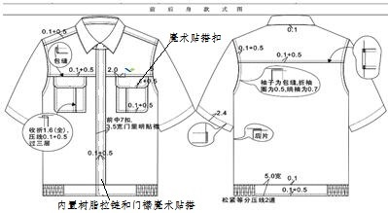
图示1 短袖工装衬衫样式图
1.3号型及规格
1.3.1号型
男袖休闲衬衫采用GB/T 1335.2-1997标准中A.B.C三个体型。身高以5.0cm分档、胸围以4.0cm分档。腰围4.0cm分档，身高与腰围搭配成5/4号型系列，身高与腰围搭配成5.4/5.2号型系列。
号型：上衣用身高、胸围、体型表示
示例：175/96A 175/86A
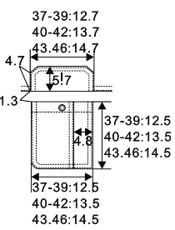
1.3.2工艺明细

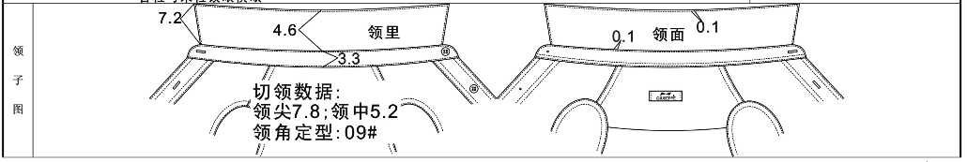
图示1 短袖工装衬衫样式图
1.4技术参数
名称 | 工装衬衫 | 规 格
 |  | 成份 | 纱支 | 颜色
面料 | 全棉斜纹（含防静电丝） | 100%棉 | 参照标样 | 浅蓝色，见标样

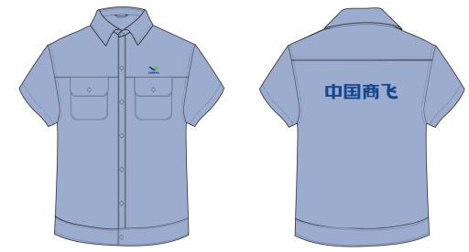
增加塑料拉链 纽扣改为魔术贴
增加塑料拉链
增加塑料拉链
增加塑料拉链

航线维修长袖工装衬衫要求
参照短袖款式，袖长按国标号型。（增加塑料拉链&纽扣改为魔术贴）
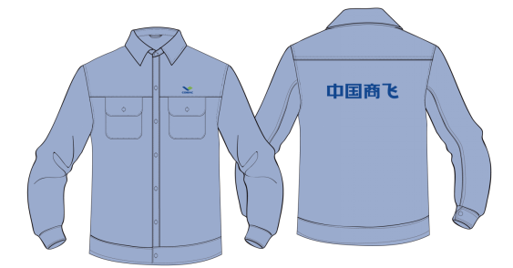

航线维修工装裤要求
3.1标样
航线维修工装裤实物样品
3.2 样式
工装裤的样式如图示1所示
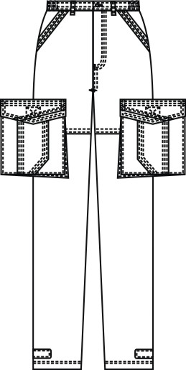
图示1 男工装休闲裤样式图

3.3号型及规格
3.3.1号型
男工装休闲裤采用GB/T 1335.2-1997标准中A.B.C三个体型。身高以5.0cm分档、胸围以4.0cm分档。腰围4.0cm分档，身高与腰围搭配成5/4号型系列，身高与腰围搭配成5.4/5.2号型系列。
号型：裤子用身高、腰围、体型表示。
示例：175/96A 175/86A

3.3.2 规格尺寸表
男工装裤成品规格尺寸表
单位：厘米
规格 | 号型 | 裤长 | 腰围 | 臀围 | 净臀围 | 直裆 | 脚口
99/68A | 165/66A | 99.00 | 68.00 | 97.60 | 83.60 | 22.10 | 22.00
99/70A | 165/68A | 99.00 | 70.00 | 99.20 | 85.20 | 22.40 | 22.00
99/72A | 165/70A | 99.00 | 72.00 | 100.80 | 86.80 | 22.70 | 22.50
99/74A | 165/72A | 99.00 | 74.00 | 102.40 | 88.40 | 23.00 | 22.50
102/76A | 170/74A | 102.00 | 76.00 | 104.00 | 90.00 | 23.30 | 23.00
102/78A | 170/76A | 102.00 | 78.00 | 105.60 | 91.60 | 23.60 | 23.00
102/80A | 170/78A | 102.00 | 80.00 | 107.20 | 93.20 | 23.90 | 23.50
102/82A | 170/80A | 102.00 | 82.00 | 108.80 | 94.80 | 24.20 | 23.50
105/84A | 175/82A | 105.00 | 84.00 | 110.40 | 96.40 | 24.50 | 24.00
105/86A | 175/84A | 105.00 | 86.00 | 112.00 | 98.00 | 24.80 | 24.00
105/88A | 175/86A | 105.00 | 88.00 | 113.60 | 99.60 | 25.10 | 24.50
105/90A | 175/88A | 105.00 | 90.00 | 115.20 | 101.20 | 25.40 | 24.50
108/92A | 180/90A | 108.00 | 92.00 | 116.80 | 102.80 | 25.70 | 25.00
108/94A | 180/92A | 108.00 | 94.00 | 118.40 | 104.40 | 26.00 | 25.00
108/96A | 180/94A | 108.00 | 96.00 | 120.00 | 106.00 | 26.30 | 25.50
108/98A | 180/96A | 108.00 | 98.00 | 121.60 | 107.60 | 26.60 | 25.50
111/100A | 185/98A | 111.00 | 100.00 | 123.20 | 109.20 | 26.90 | 26.00
111/102A | 185/100A | 111.00 | 102.00 | 124.80 | 110.80 | 27.20 | 26.00
100/76B | 165/74B | 100.00 | 76.00 | 102.00 | 88.00 | 22.70 | 22.50
100/78B | 165/76B | 100.00 | 78.00 | 103.40 | 89.40 | 23.00 | 22.50
100/80B | 165/78B | 100.00 | 80.00 | 104.80 | 90.80 | 23.30 | 23.00
100/82B | 165/80B | 100.00 | 82.00 | 106.20 | 92.20 | 23.60 | 23.00
103/84B | 170/82B | 103.00 | 84.00 | 107.60 | 93.60 | 23.90 | 23.50
103/86B | 170/84B | 103.00 | 86.00 | 109.00 | 95.00 | 24.20 | 23.50
103/88B | 170/86B | 103.00 | 88.00 | 110.40 | 96.40 | 24.50 | 24.00
103/90B | 170/88B | 103.00 | 90.00 | 111.80 | 97.80 | 24.80 | 24.00
106/92B | 175/90B | 106.00 | 92.00 | 113.20 | 99.20 | 25.10 | 24.50
106/94B | 175/92B | 106.00 | 94.00 | 114.60 | 100.60 | 25.40 | 24.50
106/96B | 175/94B | 106.00 | 96.00 | 116.00 | 102.00 | 25.70 | 25.00
106/98B | 175/96B | 106.00 | 98.00 | 117.40 | 103.40 | 26.00 | 25.00
109/100B | 180/98B | 109.00 | 100.00 | 118.80 | 104.80 | 26.30 | 25.50
109/102B | 180/100B | 109.00 | 102.00 | 120.20 | 106.20 | 26.60 | 25.50
109/104B | 180/102B | 109.00 | 104.00 | 121.60 | 107.60 | 26.90 | 26.00
109/106B | 180/104B | 109.00 | 106.00 | 123.00 | 109.00 | 27.20 | 26.00
112/108B | 185/106B | 112.00 | 108.00 | 124.40 | 110.40 | 27.50 | 26.50
112/110B | 185/108B | 112.00 | 110.00 | 125.80 | 111.80 | 27.80 | 26.50

3.4工艺明细
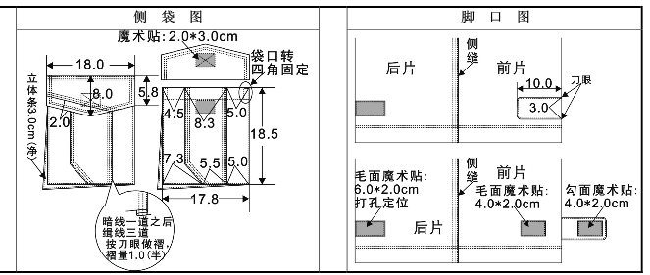
3.5技术参数
名称 | 工装裤 | 规 格
 |  | 成份 | 纱支 | 颜色
面料（薄款） | 全棉弹力斜纹纱卡（含防静电丝） | 97%棉 3%氨纶， | 32s*32s+40D | 藏青色

